

[ online shopping ]

.



|  |  |
| --- | --- |
| Name: | Joshi Krish Sanjaykumar |
| Division: | DITA |
| Enrollment No: | 2202021000104 |
|  | |

|  |  |  |
| --- | --- | --- |
| Chapter | Topic | Page No |
| Ch-1 | **Introduction** | 3 |
| 1.1 | Purpose | 3 |
| 1.2 | Scope | 3 |
| 1.3 | Definition | 3 |
| 1.4 | Overview | 4 |
| Ch-2 | **Overall Description** | 4 |
| 2.1 | Product perspective | 4 |
| 2.2 | Product | 4 |
| Ch-3 | **Specific requirement** | 5 |
| 3.1 | Functional requirement | 5 |
| 3.2 | Non-functional requirement | 6 |
| Ch-4 | **Interface requirement** | 7 |
| 4.1 | Software | 7 |
| 4.2 | Hardware | 7 |
| 4.3 | Communication | 7 |
| Ch-5 | **Conclusion & reference** | 8 |

***1.Introduction***

1.1 Purpose:

This document is meant to delineate the feature of online shopping, so as to serve as a guide to the developers on one hand and a software validation document for the prospective client on the other.

* The online shopping for electronics item shop web application is intended to provide complete solution for vendors as well as customers through a single get way using the internet. It will enable vendors to setup online shops, customer to browse through the shop and purchase them online without having to visit the shop physically. The administration module will enable a system administrator to approve and reject request for new shops and maintain various lists of shop category.

1.2 Scope:

The scope of the study on shopping online is to examine customer behavior, analyze customer satisfaction and measure the problems faced by customers while buying good online.

1.3 Definition:

Online shopping: -Online shopping involves purchasing product or service over the internet.

1.5Overview:

This system provides an easy solution for customers to buy the product without going to the shop and also to the shop owner to sale the product.

This proposed system can be used by any have a user and it does not require any educational level, experience or technical expertise in computer field but it will be of good use if user has the good knowledge of how to operate a computer.

***2.OVERALL DESCRIPTION***

The online shopping application enables vendors to set up online shops, customers to browse through the shop, and a system administer to approve and reject request for new shops and maintain lists of shop categories. Also the developer is designing an online shopping site to manage the items in the shop and also help customers to purchase them online without visiting the shop physically. The online shopping system will use the internet as the sole method for selling goods to its consumers.

2.1 Product perspective:

This product aimed toward a person who don’t want to visit the shop as he might don’t get time for that or might not interested in visiting there and dealing with lot of formalities.

2.2 Product functions: 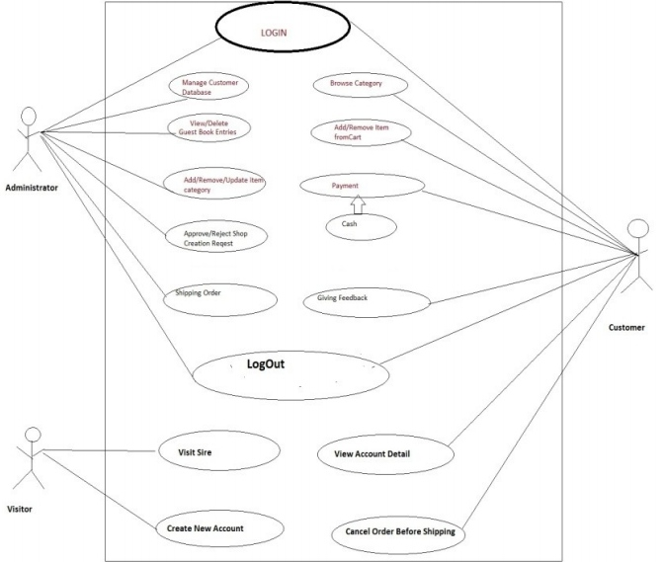

***3.Specific requirement:***

3.1 Functional requirement:

This section provides requirement over view of the system. Various functional modules that can be implemented by the system.

3.1 Description:

3.1.1 Registration

If customer wants to buy the product then he/she must be registered, unregistered user can’t go to the shopping cart.

3.1.2 Login

Customer logins to the system by entering valid user id and password for the shopping.

3.1.3 Changes to cart

Changes to cart means the customer after login or registration can make order or cancel order of the product from to the shopping cart.

3.1.4 Payment

In this system we are dealing the mode of payment by cash. We will extend this to credit card, debit card etc in the future.

3.1.5 Logout

After ordering or surfing for customer to the product logout.

3.2 Non-functional requirement

Following Non-functional requirement will be there in the insurance to the internet:

* Secure access to consumer’s confidential data.
* 24*7 avaibillity.
* Better component design to get better performance at peak time.
* Flexible service based architecture will be highly desirable for future extension. Non-fuctional requirement define system properties and constraints.

Various other Non-functional reqirement are:

* Security
* Reliability
* Maintainbility
* Portability
* Extensibility
* Reusability
* Compatibility
* Reassurance utilization

***4.Interface requirement:***

**Software interface:**

1. Operating system: Windows7 ultimate which supports networking.
2. Java development toolkit.

**Hardware interface:**

Hardware requirement for insurance on internet will be same for both parties which are as follow:

Processor: Dual code

RAM:2GB

Hard Disk:320GB

NIC: for each party

**Communication interface:**

The two parties should be connected by LAN or WAN for the communication purpose.



***5. reference & conclusion***

5.1 reference:

<https://www.scribd.com/document/128224287/Srs-of-Online-Shopping>

<https://www.researchgate.net/publication/375756219_Online_Shopping_System_SRS_Report>

<https://chat.openai.com/>

5.2 Conclusion:

This SRS document is used to give details regarding online shopping. In this all functional and Non-functional requirement are specified in order to get a clear-cut idea to develop a project.